**Quiz # 4: Student ID: ________________ Date: 30/06/2019**

**___________________________________________________________________**

1. **Consider following knapsack problem; A bag of total capacity 15kg; You have to select from different items as given in table, so that you gain maximum profit using hill climbing algorithm. What will be initial state? What heuristics function you will use? Solve up to goal state.**

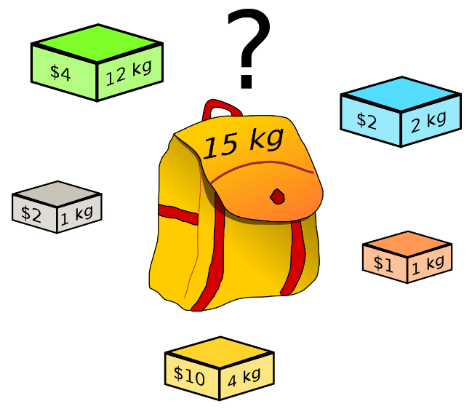

|  |  |  |
| --- | --- | --- |
| Item Name | Item Weight | Item Value/Price |
| A | 12 kg | $4 |
| B | 2 kg | $2 |
| C | 1 kg | $2 |
| D | 4 kg | $10 |
| E | 1 kg | $1 |